Focus is on farm mechanisation: Saxena
STAFF REPORTER

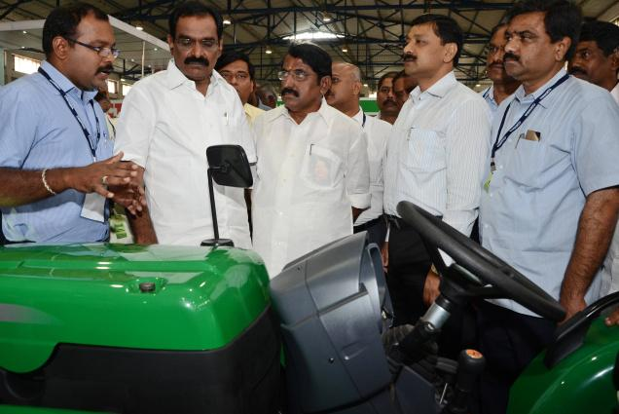
The HinduAgriculture Minister S. Damodaran at a stall of ‘Agri Intex 2013’ in the city on Thursday. Photo: M. Periasamy

‘Coimbatore should come up with more equipment suited for farmers’
Agriculture Production Commissioner and Principal Secretary, State Department of Agriculture, Sandeep Saxena stressed the need for developing farm equipment for the Indian farmer with small land holdings, here on Thursday.
Speaking at the inauguration of the Agri Intex 2013, an agricultural exhibition, organised by the Coimbatore District Small Industries Association (Codissia) in association with the Tamil Nadu Agricultural University (TNAU) at the Codissia Trade Fair Complex, he said that entrepreneurs in Coimbatore were capable of making such machinery.
“Shortage of agricultural labour coupled with the limitation of small and fragmented land holdings is making agriculture a difficult proposition today. It is the duty of every citizen to make the farming community sustainable, if not rich,” Mr. Saxena said.
The State Government would soon come out with a policy to address the issues of the farmers, said the Agriculture Production Commissioner.
Minister for Agriculture S. Damodaran stressed the importance of use of farm implements in agriculture in the light of shortage of agricultural labour.
“Studies show that though there are 82 million farm families in India, only 36 lakh tractors are in use. There is a felt need for farm mechanisation,” the Minister added.
Transfer of technologies and innovations from lab to land was not happening for want of small modifications, corrections and suitability, Mr. Damodaran said.
Director of Agriculture M Rajendran said that the State Government had for the first time initiated measures to test the soil, understand the fertility and advise farmers appropriately.
“Junior researchers are working on this on a war-footing and soil-health cards are being issued to the farmers,” he said.
K. Ramasamy, Vice-Chancellor of TNAU, stressed the need for strengthening production of small millets. He sought the State Government’s support for fixing the Minimum Support Price for small millets.
Nearly 19 departments of the university had put up stalls at the exhibition to give information on the latest know-how on agriculture.
The exhibition has 225 participants who have put up nearly 400 stalls that have a wide range of farm implements and tractors. A demonstration plot on integrated farming is also on display.
It has two concurrent events — one on food processing and the other on animal husbandry. Companies from the U.S., Japan and Israel have put up four stalls.
The exhibition will be open till July 14 from 9.30am to 6pm.

